**GENERATIVE AI COURSE**

**ASSIGNEMENTS**

**NAME: Sanskriti Sajlal**

**COLLEGE: VIT Vellore**

**Beginner: Introduction To Generative AI Learning Path:**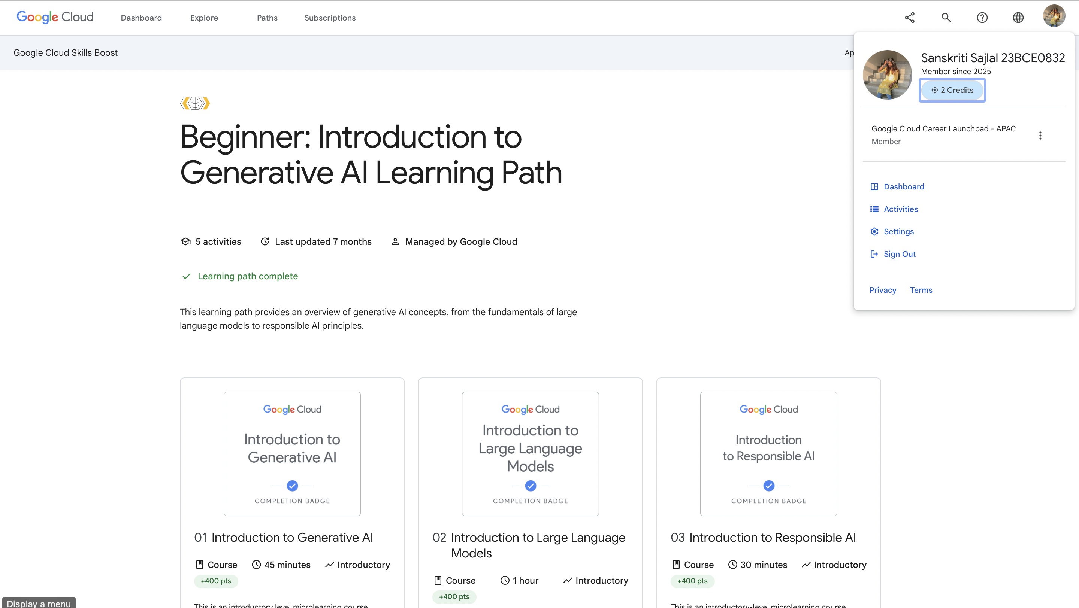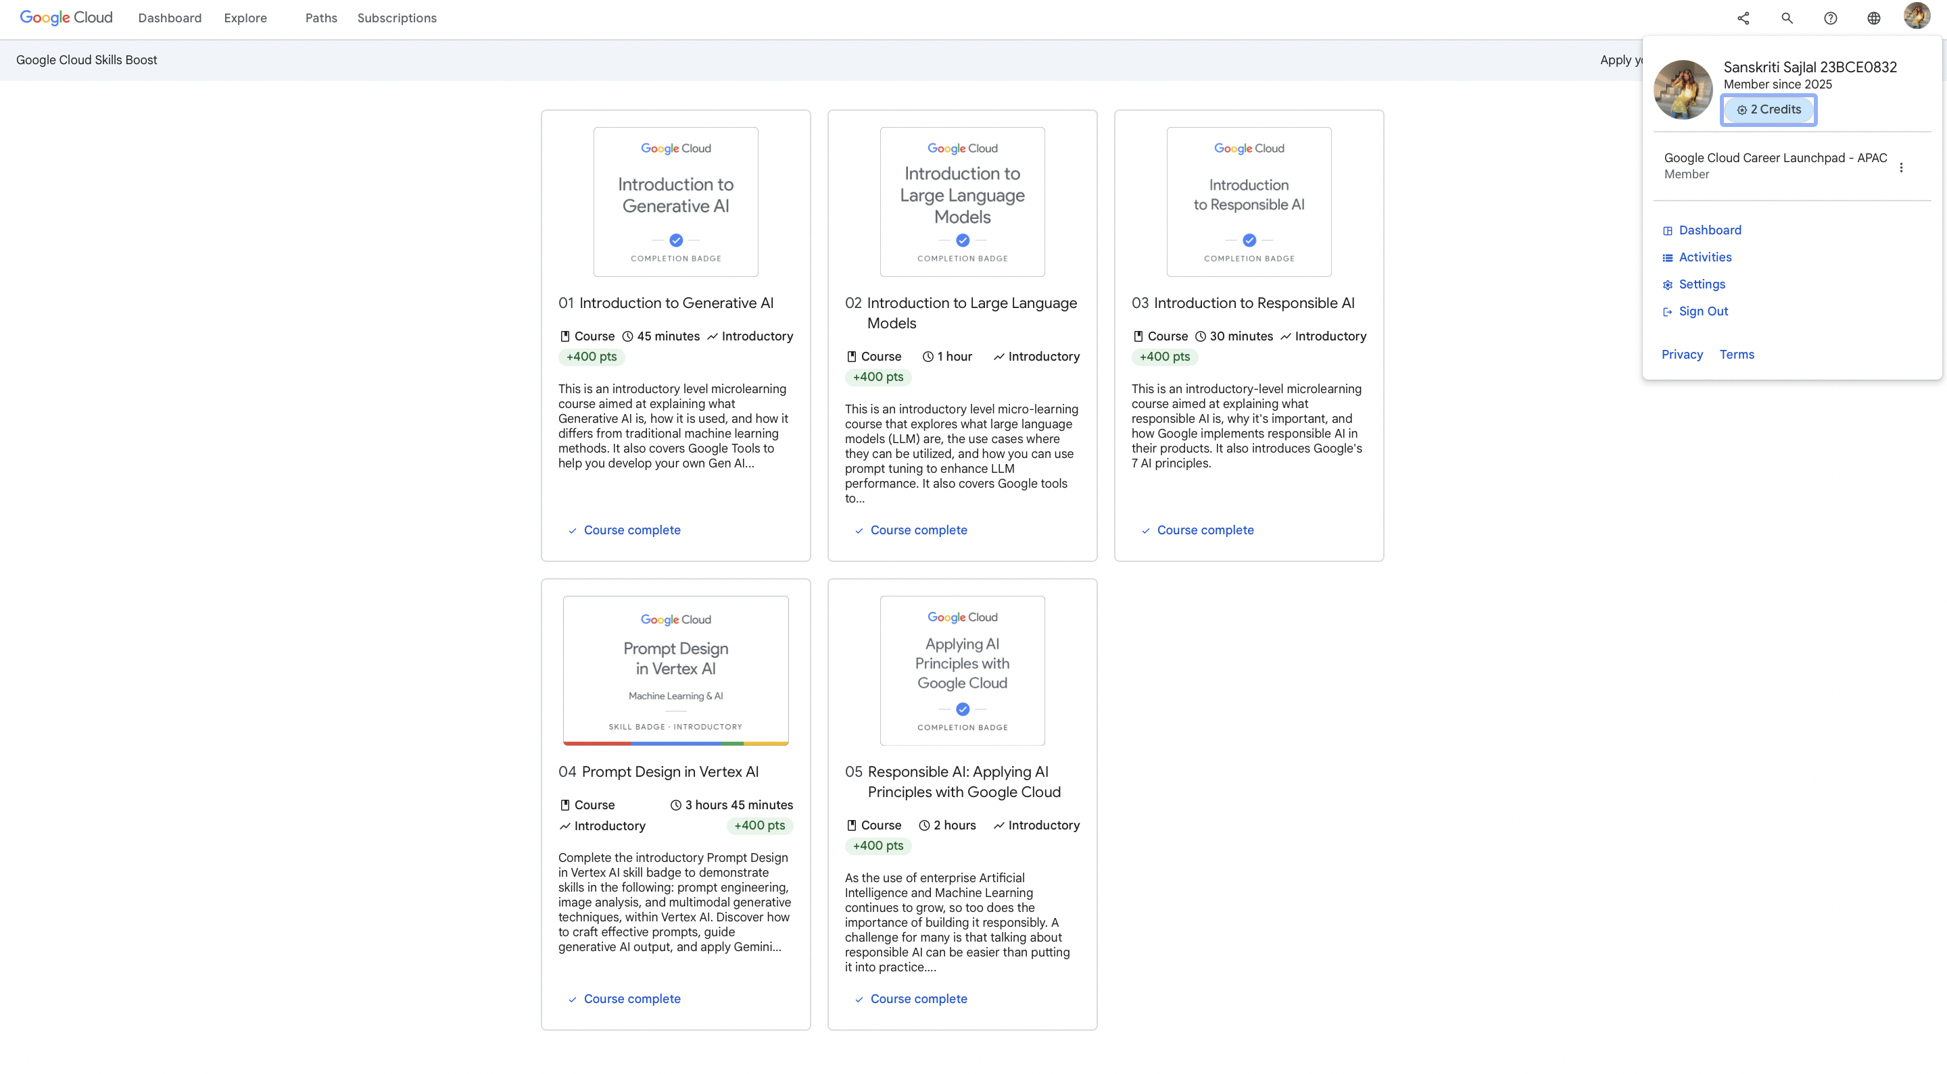

**Intermediate: Gemini For Google Cloud Learning Path:**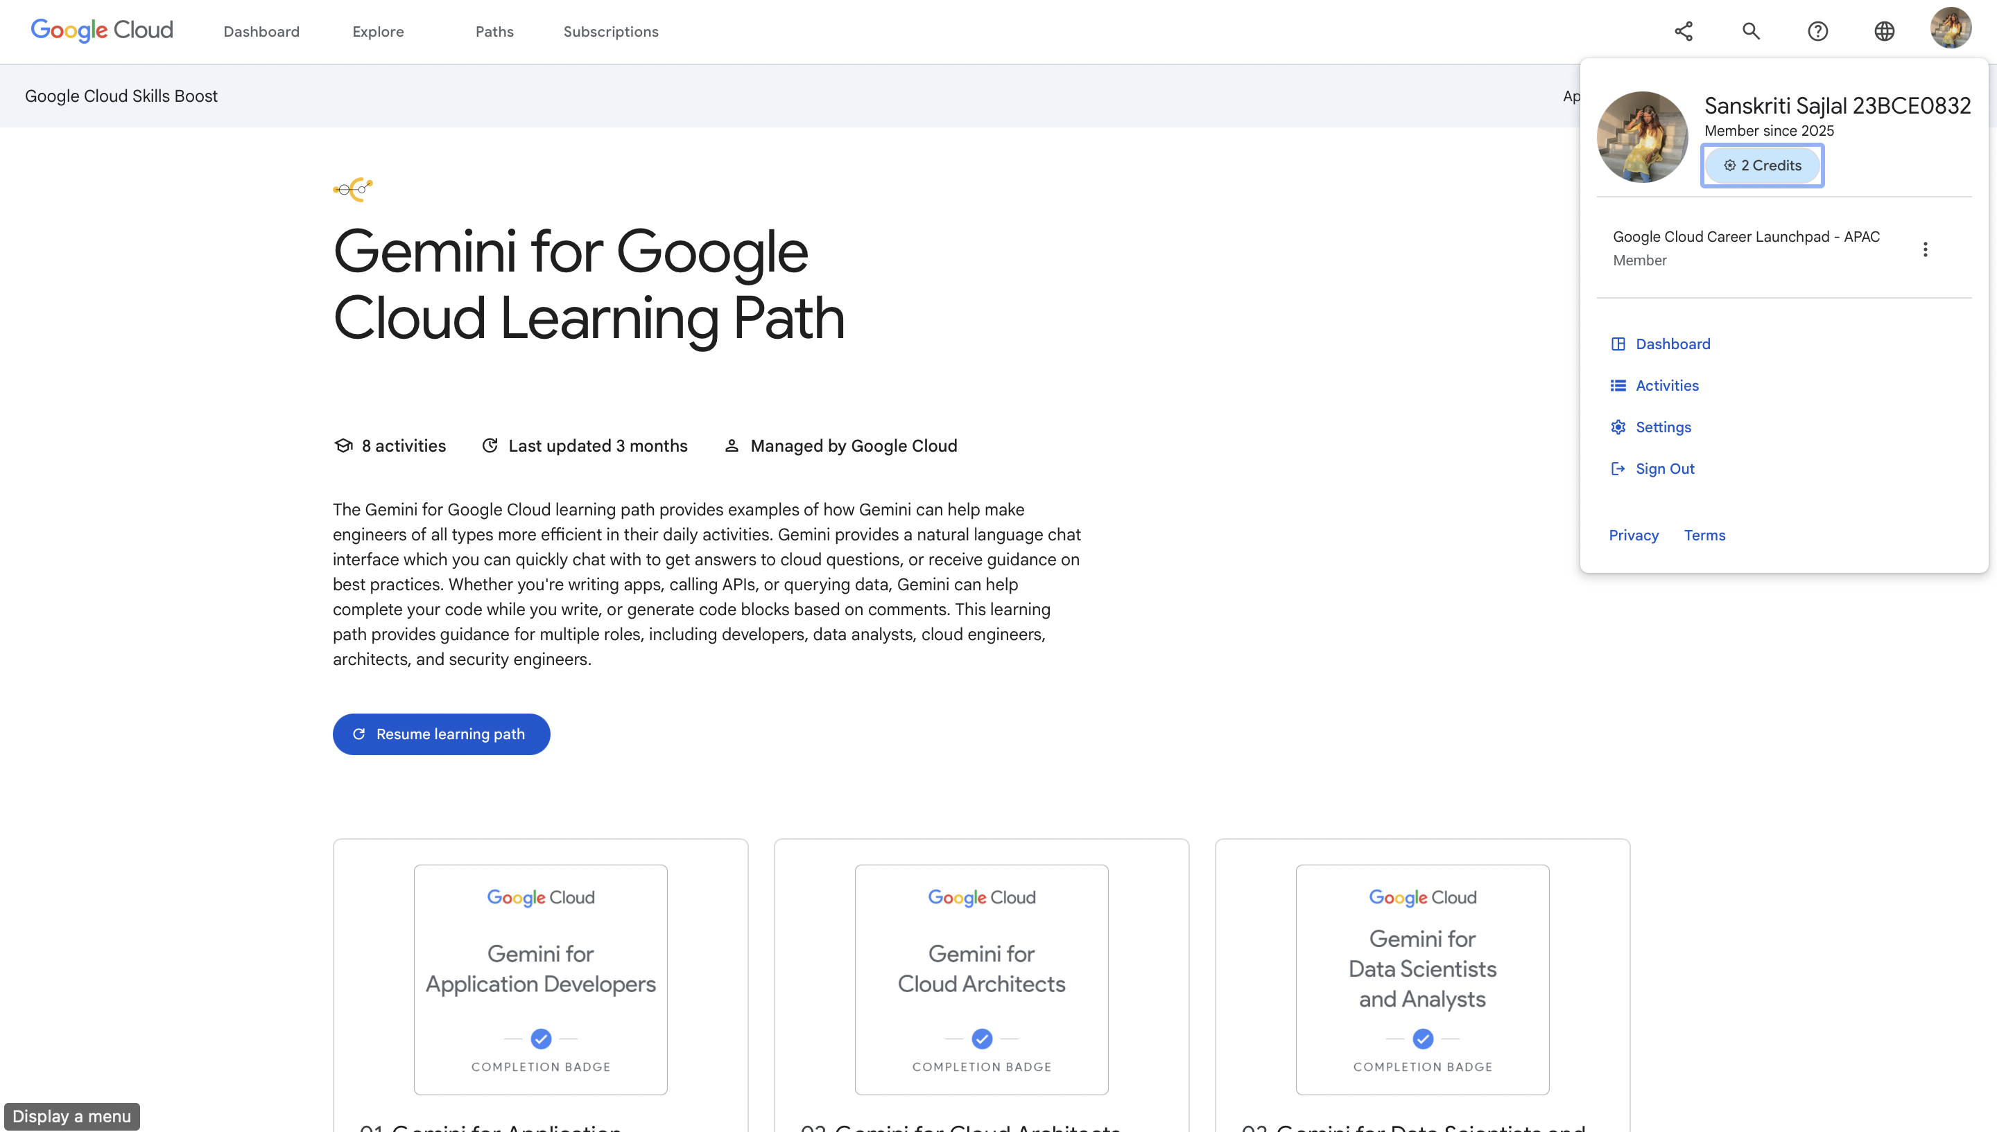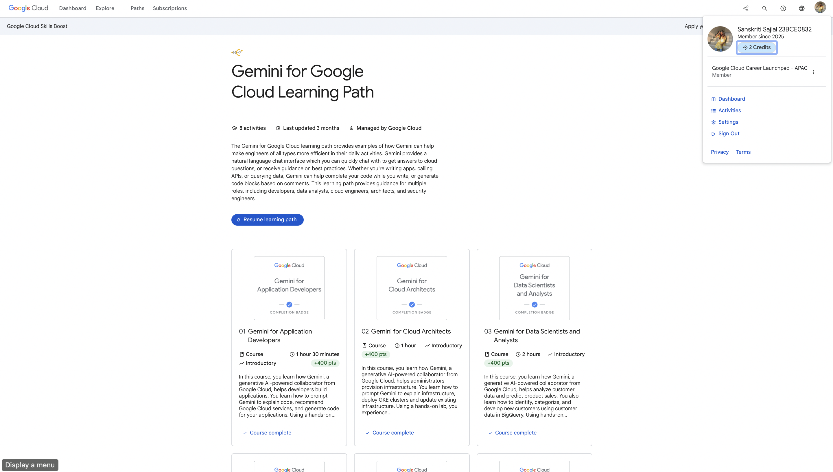

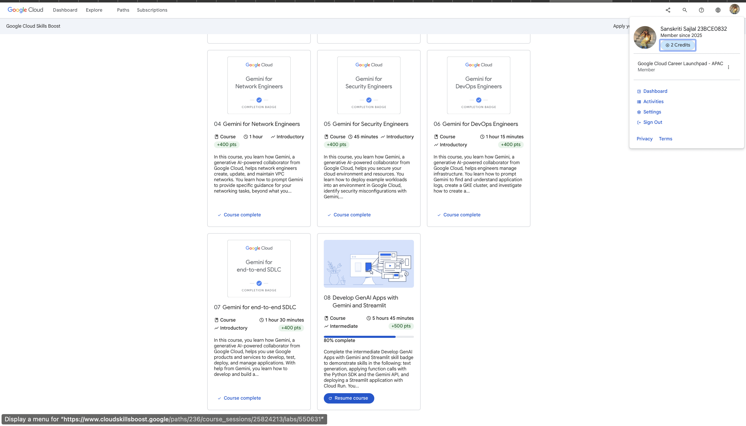

**Advanced: Generative AI For Developers Learning Path:**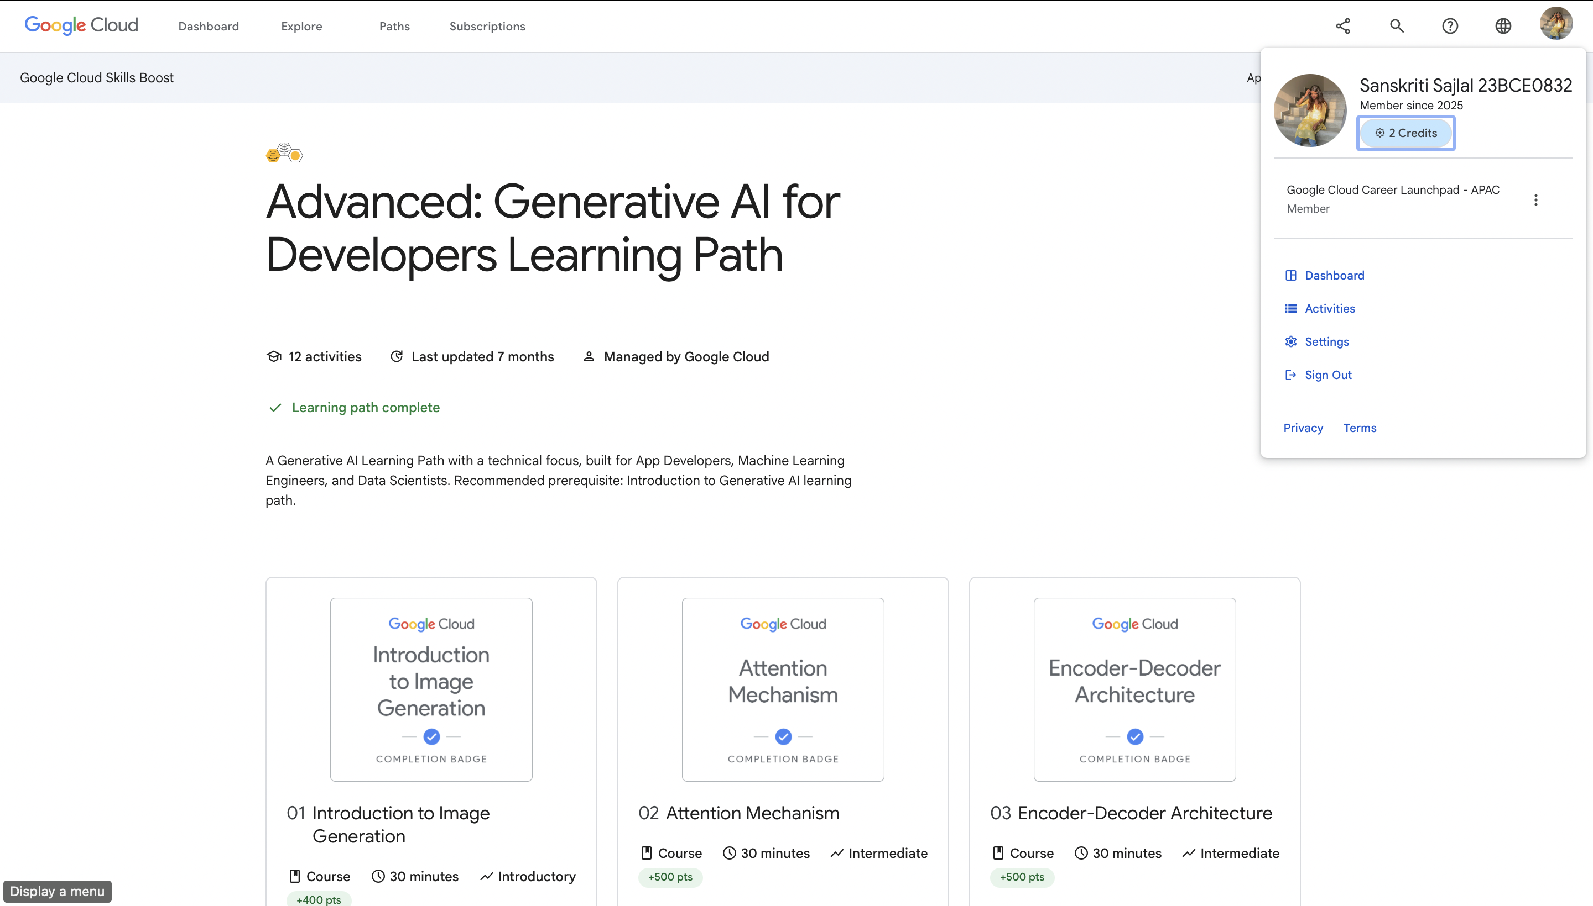

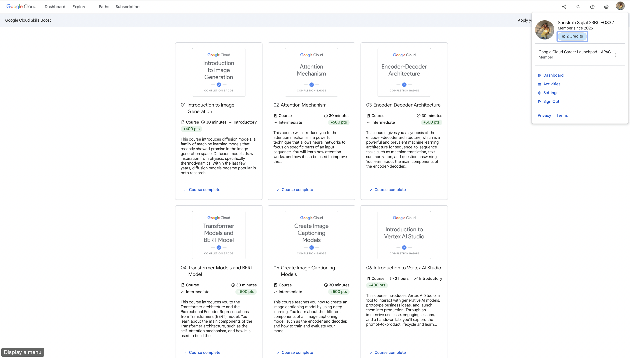

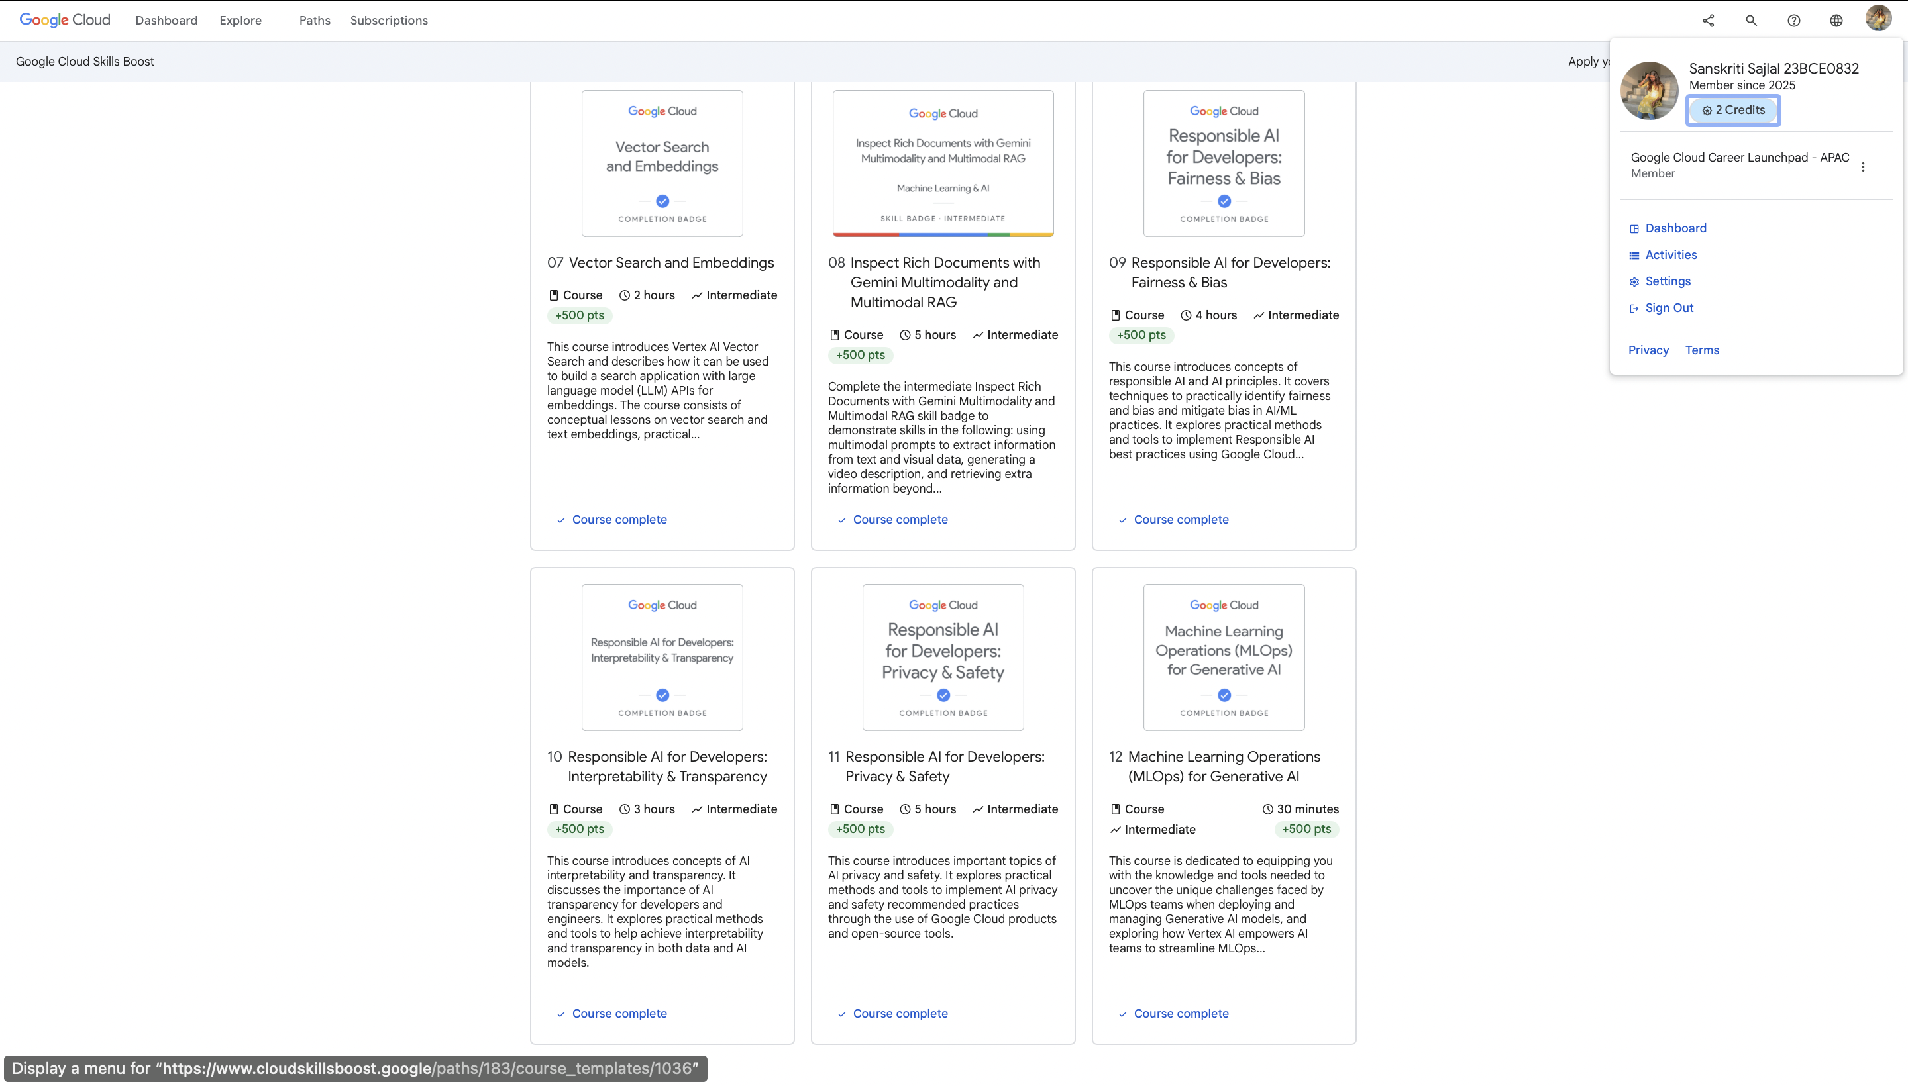

**Getting Started With Artificial Intelligence 2025:**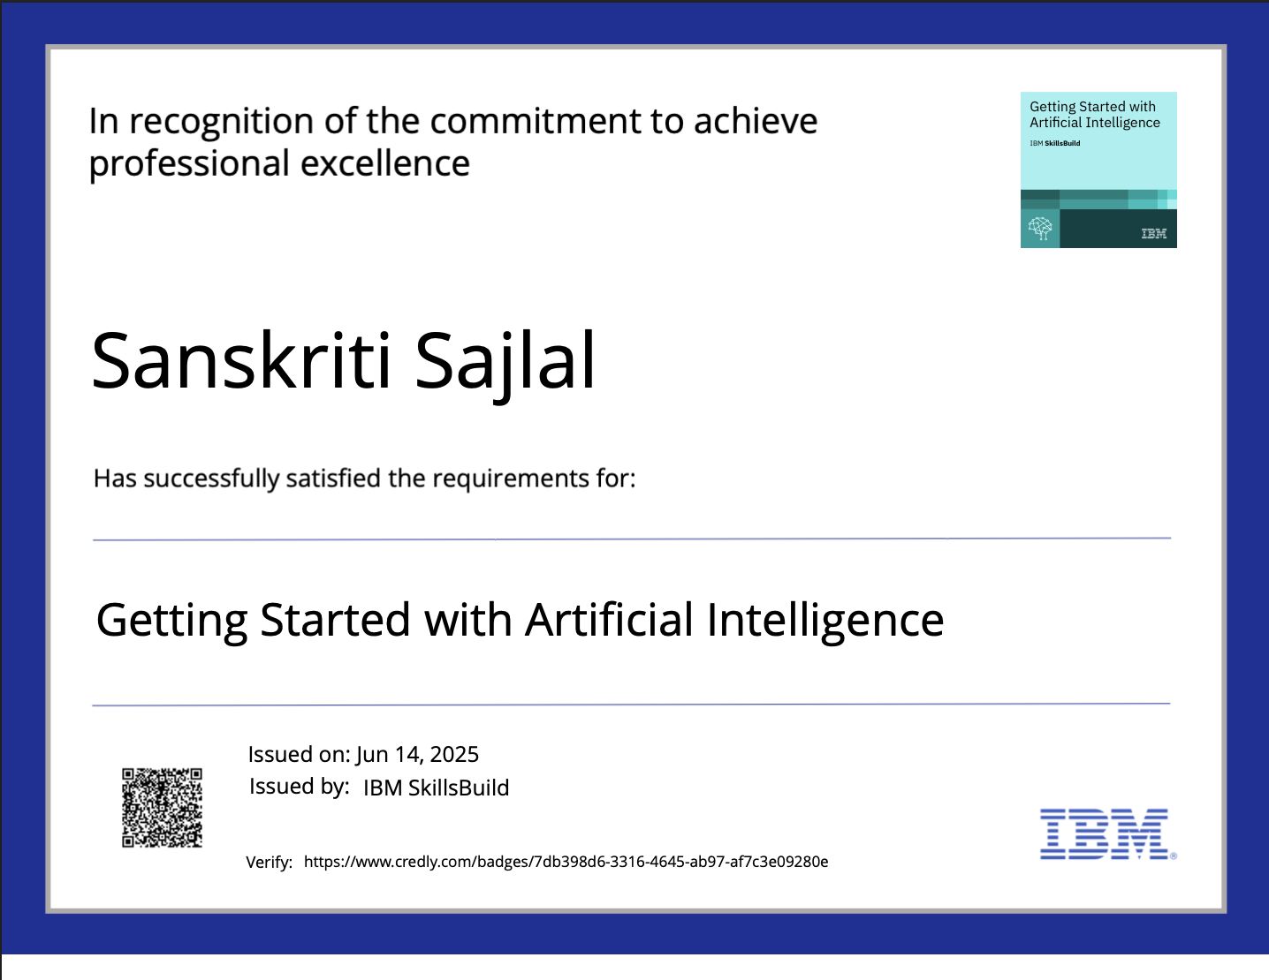

**IBM Cloud 2025:**